Задания заочного этапа многопрофильной олимпиады КГУ
в 2019-2020 учебном году

Предмет: Английский язык

Задания 2019-2020 уч. года
Этап: I (заочный, отборочный)
Выполните предложенные задания и внесите Ваши варианты ответов в бланк ответов (Answer Sheet).

Тур 1 (фонетика, аудирование и страноведение)
9-11 классы
Задание 1. Listening Comprehension (Part 1)
СКАЧАТЬ и ПРОСЛУШАТЬ АУДИОЗАПИСЬ
Questions 1-4 are based on Audio File 1 and Table 1 on your answer sheet.
Listen to four speakers talking about the typical characteristics of people from their country (England, Ireland, Scotland, and the USA).
For questions 1-4, match each speaker with their nationality. Write the correct name of the NATIONALITY in boxes 1-4 on your answer sheet.
Fill in column 2 in the Table providing AT LEAST ONE example of the accent from the AUDIO. Write the example or your explanation in the boxes in front of the name of the nationality on your answer sheet.
Fill in column 3 in the Table providing AT LEAST ONE example of the national trait of character mentioned the AUDIO. Write a word or phrase in the boxes in front of the name of the nationality on your answer sheet.
Fill in column 4 in the Table providing AT LEAST ONE detail from their history mentioned the AUDIO. Write a phrase or sentence in in the boxes in front of the name of the nationality on your answer sheet.

Model
1. | Russian | The sound [р] instead of [r] in the word Russia | hospitable | The Great October Revolution of 1917

Mark your answers on the separate answer sheet.
Задание 2. Phonetics and Country Studies (Part 2)
Questions 5-16 are based on the following task.
Below are some names of British places given in transcription. For questions 5-16, write down the names of these places in spelling.

5. | ['glɒstә]
6. | ['lestә]
7. | ['wʊstә]
8. | [lә'neθlɪ]
9. | ['da:bɪ]
10. | ['dʌrәm]
11. | ['tɒtnәm]
12. | ['raɪzlɪp]
13. | ['lʌfbrә]
14. | ['ma:li:bәn]
15. | ['aɪlә]
16. | ['nɔ:ridʒ]

Mark your answers on the separate answer sheet.
Задание 3. Country Studies (Part 3)
Question 17 is based on the following task.
For question 17, write down the name of a British novel that was set in one of these places. In 50-60 words explain what happened in this place. Do not plagiarize!
Mark your answer on the separate answer sheet.
Тур 2 (чтение, лексика и письмо)
9-11 классы
Задание 1. Reading Comprehension and World Culture (Part 1)
Questions 1-5 are based on the following texts.
For questions 1-5, read the following extracts from famous books and write down their original titles and authors. Some of the extracts are given IN TRANSLATION. The proper names have been deleted deliberately.
1.
As he entered the chamber of his friend, […] cast around one eager and searching glance in quest of the expected marvels, but nothing more than common met his view.
“It is well,” said the abbé; “we have some hours before us—it is now just a quarter past twelve o’clock.” Instinctively […] turned round to observe by what watch or clock the abbé had been able so accurately to specify the hour.
“Look at this ray of light which enters by my window,” said the abbé, “and then observe the lines traced on the wall. Well, by means of these lines, which are in accordance with the double motion of the earth, and the ellipse it describes round the sun, I am enabled to ascertain the precise hour with more minuteness than if I possessed a watch; for that might be broken or deranged in its movements, while the sun and earth never vary in their appointed paths.”
This last explanation was wholly lost upon […], who had always imagined, from seeing the sun rise from behind the mountains and set in the Mediterranean, that it moved, and not the earth. A double movement of the globe he inhabited, and of which he could feel nothing, appeared to him perfectly impossible. Each word that fell from his companion’s lips seemed fraught with the mysteries of science, as worthy of digging out as the gold and diamonds in the mines of Guzerat and Golconda, which he could just recollect having visited during a voyage made in his earliest youth.
“Come,” said he to the abbé, “I am anxious to see your treasures.”
The abbé smiled, and, proceeding to the disused fireplace, raised, by the help of his chisel, a long stone, which had doubtless been the hearth, beneath which was a cavity of considerable depth, serving as a safe depository of the articles mentioned to […].

2.
… At the very moment when [ …] (the editor) was telling the poet how the Aztecs used to model figurines of Vitzli-Putzli out of dough - the first man appeared in the avenue.
Afterwards, when it was frankly too late, various bodies collected their data and issued descriptions of this man. As to his teeth, he had platinum crowns on his left side and gold ones on his tight. He wore an expensive grey suit and foreign shoes of the same colour as his suit. His grey beret was stuck jauntily over one ear and under his arm he carried a walking-stick with a knob in the shape of a poodle's head. He looked slightly over forty. Crooked sort of mouth. Clean-shaven. Dark hair. Right eye black, left eye for some reason green. Eyebrows black, but one higher than the other. In short - a foreigner.
As he passed the bench occupied by the editor and the poet, the foreigner gave them a sidelong glance, stopped and suddenly sat down on the next bench a couple of paces away from the two friends.
'A German,'' thought [ …] (the editor). ' An Englishman. ...' thought [ …] (the poet). ' Phew, he must be hot in those gloves!'
The stranger glanced round the tall houses that formed a square round the pond, from which it was obvious that he seeing this locality for the first time and that it interested him. His gaze halted on the upper storeys, whose panes threw back a blinding, fragmented reflection of the sun which was setting on [ …] (the editor) for ever ; he then looked downwards to where the windows were turning darker in the early evening twilight, smiled patronisingly at something, frowned, placed his hands on the knob of his cane and laid his chin on his hands.
'You see, […],' said […] (the editor),' you have written a marvellously satirical description of the birth of Jesus, the son of God, but the whole joke lies in the fact that there had already been a whole series of sons of God before Jesus, such as the Phoenician Adonis, the Phrygian Attis, the Persian Mithras. Of course not one of these ever existed, including Jesus, and instead of the nativity or the arrival of the Magi you should have described the absurd rumours about their arrival. But according to your story the nativity really took place! '

3.
On an exceptionally hot evening early in July a young man came out of the garret in which he lodged in S. Place and walked slowly, as though in hesitation, towards K. bridge.
He had successfully avoided meeting his landlady on the staircase. His garret was under the roof of a high, five-storied house and was more like a cupboard than a room. The landlady who provided him with garret, dinners, and attendance, lived on the floor below, and every time he went out he was obliged to pass her kitchen, the door of which invariably stood open. And each time he passed, the young man had a sick, frightened feeling, which made him scowl and feel ashamed. He was hopelessly in debt to his landlady, and was afraid of meeting her.
This was not because he was cowardly and abject, quite the contrary; but for some time past he had been in an overstrained irritable condition, verging on hypochondria. He had become so completely absorbed in himself, and isolated from his fellows that he dreaded meeting, not only his landlady, but anyone at all. He was crushed by poverty, but the anxieties of his position had of late ceased to weigh upon him. He had given up attending to matters of practical importance; he had lost all desire to do so. Nothing that any landlady could do had a real terror for him. But to be stopped on the stairs, to be forced to listen to her trivial, irrelevant gossip, to pestering demands for payment, threats and complaints, and to rack his brains for excuses, to prevaricate, to lie—no, rather than that, he would creep down the stairs like a cat and slip out unseen.
This evening, however, on coming out into the street, he became acutely aware of his fears.
“I want to attempt a thing like that and am frightened by these trifles,” he thought, with an odd smile. “Hm... yes, all is in a man’s hands and he lets it all slip from cowardice, that’s an axiom. It would be interesting to know what it is men are most afraid of. Taking a new step, uttering a new word is what they fear most.... But I am talking too much. It’s because I chatter that I do nothing. Or perhaps it is that I chatter because I do nothing. I’ve learned to chatter this last month, lying for days together in my den thinking... of Jack the Giant-killer. Why am I going there now? Am I capable of that? Is that serious? It is not serious at all. It’s simply a fantasy to amuse myself; a plaything! Yes, maybe it is a plaything.” …

4.
…The next morning at daybreak a thick fog was clinging to the surface of the river. A portion of the vapors that saturated the air were condensed by the cold, and lay as a dense cloud on the water. But the rays of the sun soon broke through the watery mass and melted it away.
A tongue of land, sharply pointed and bristling with bushes, projected into the uniting streams. The swifter waters of the Waipa rushed against the current of the Waikato for a quarter of a mile before they mingled with it; but the calm and majestic river soon quieted the noisy stream and carried it off quietly in its course to the Pacific Ocean.
When the vapor disappeared, a boat was seen ascending the current of the Waikato. It was a canoe seventy feet long, five broad, and three deep; the prow raised like that of a Venetian gondola, and the whole hollowed out of a trunk of a kahikatea. A bed of dry fern was laid at the bottom. It was swiftly rowed by eight oars, and steered with a paddle by a man seated in the stern.
This man was a tall Maori, about forty-five years of age, broad-chested, muscular, with powerfully developed hands and feet. His prominent and deeply-furrowed brow, his fierce look, and sinister expression, gave him a formidable aspect.
Tattooing, or “moko,” as the New Zealanders call it, is a mark of great distinction. None is worthy of these honorary lines, who has not distinguished himself in repeated fights. The slaves and the lower class can not obtain this decoration. Chiefs of high position may be known by the finish and precision and truth of the design, which sometimes covers their whole bodies with the figures of animals. Some are found to undergo the painful operation of “moko” five times. The more illustrious, the more illustrated, is the rule of New Zealand.
Dumont D’Urville has given some curious details as to this custom. He justly observes that “moko” is the counterpart of the armorial bearings of which many families in Europe are so vain. But he remarks that there is this difference: the armorial bearings of Europe are frequently a proof only of the merits of the first who bore them, and are no certificate of the merits of his descendants; while the individual coat-of-arms of the Maori is an irrefragible proof that it was earned by the display of extraordinary personal courage.
The practice of tattooing, independently of the consideration it procures, has also a useful aspect. It gives the cutaneous system an increased thickness, enabling it to resist the inclemency of the season and the incessant attacks of the mosquito.
As to the chief who was steering the canoe, there could be no mistake. The sharpened albatross bone used by the Maori tattooer, had five times scored his countenance. He was in his fifth edition, and betrayed it in his haughty bearing.
His figure, draped in a large mat woven of “phormium” trimmed with dogskins, was clothed with a pair of cotton drawers, blood-stained from recent combats. From the pendant lobe of his ears hung earrings of green jade, and round his neck a quivering necklace of “pounamous,” a kind of jade stone sacred among the New Zealanders. At his side lay an English rifle, and a “patou-patou,” a kind of two-headed ax of an emerald color, and eighteen inches long. Beside him sat nine armed warriors of inferior rank, ferocious-looking fellows, some of them suffering from recent wounds. They sat quite motionless, wrapped in their flax mantles. Three savage-looking dogs lay at their feet. The eight rowers in the prow seemed to be servants or slaves of the chief. They rowed vigorously, and propelled the boat against the not very rapid current of the Waikato, with extraordinary velocity.
In the center of this long canoe, with their feet tied together, sat ten European prisoners closely packed together…

5.
My first quarter at [ …] seemed an age; and not the golden age either; it comprised an irksome struggle with difficulties in habituating myself to new rules and unwonted tasks. The fear of failure in these points harassed me worse than the physical hardships of my lot; though these were no trifles.
During January, February, and part of March, the deep snows, and, after their melting, the almost impassable roads, prevented our stirring beyond the garden walls, except to go to church; but within these limits we had to pass an hour every day in the open air. Our
clothing was insufficient to protect us from the severe cold: we had no boots, the snow got into our shoes and melted there: our ungloved hands became numbed and covered with chilblains, as were our feet: I remember well the distracting irritation I endured from
this cause every evening, when my feet inflamed; and the torture of thrusting the swelled, raw, and stiff toes into my shoes in the morning. Then the scanty supply of food was distressing: with the keen appetites of growing children, we had scarcely sufficient to
keep alive a delicate invalid. From this deficiency of nourishment resulted an abuse, which pressed hardly on the younger pupils: whenever the famished great girls had an opportunity, they would coax or menace the little ones out of their portion. Many a time I
have shared between two claimants the precious morsel of brown bread distributed at tea-time; and after relinquishing to a third half the contents of my mug of coffee, I have swallowed the remainder with an accompaniment of secret tears, forced from me by the exigency of hunger.
Sundays were dreary days in that wintry season. We had to walk two miles to [ …] Church, where our patron officiated. We set out cold, we arrived at church colder: during the morning service we became almost paralysed. It was too far to return to dinner, and an allowance of cold meat and bread, in the same penurious proportion observed in our ordinary meals, was served round between the services.
At the close of the afternoon service we returned by an exposed and hilly road, where the bitter winter wind, blowing over a range of snowy summits to the north, almost flayed the skin from our faces.
I can remember Miss [ …] walking lightly and rapidly along our drooping line, her plaid cloak, which the frosty wind fluttered, gathered close about her, and encouraging us, by precept and example, to keep up our spirits, and march forward, as she said, "like stalwart soldiers." The other teachers, poor things, were generally themselves too much dejected to attempt the task of cheering others.

1. ____________________________________
2. ____________________________________
3. ____________________________________
4. ____________________________________
5. ____________________________________

Mark your answers on the separate answer sheet.

Задание 2. Vocabulary (Part 2)
Questions 6-15 are based on the following task.
For questions 6-15, match the following idioms (6-15) with their definitions from the list A-J.

6. | bluff one’s way into or out of a situation
7. | have something up one’s sleeve
8. | play one’s ace
9. | do a runner
10. | burn the candle at both ends
11. | stand out from the crowd
12. | steal the show
13. | be on thin ice
14. | call a spade a spade
15. | do a hatchet job on sth / sb

A | get all the attention and praise at an event or performance
B | use one’s advantage, especially one others do not know about
C | taking a risk
D | tell the truth about something, even if it is not polite or pleasant
E | go to bed late and get up early
F | be different from and better than others so that everyone notices you
G | pretend to be in a weaker or stronger position than is really the case
H | run away to avoid a difficult situation
I | criticise strongly and cruelly
J | have a secret plan or idea

Mark your answers on the separate answer sheet.

Задание 3. Writing (Part 3)

In Part 3, write a story (200-250 words) based on the cartoon by the famous Danish artist Herluf Bidstrup. Your story should contain all the necessary elements (see the CRITERIA pp.12-13). In your story, you must use FIVE out of the following idioms:

Like the cat that ate the canary; all fingers and thumbs; it takes two to tango; the cat's whiskers; a whizz kid; do a runner; have a bad hair day; as happy as Larry; make a pig's ear of smth.; a chapter of accidents.

Do not plagiarize!

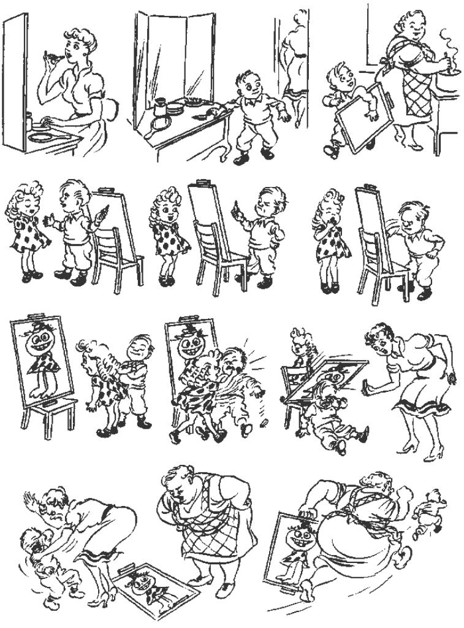
Write your story on the separate answer sheet.

Критерии оценки заданий
заочного (отборочного) этапа
2019-2020 уч. год
Тур 1 (фонетика, аудирование и страноведение)
Задание 1. Listening Comprehension (Part 1)
Каждый правильный ответ оценивается в 1 балл. Если ответ неверный, то есть, присутствуют ошибки в правописании или транскрипции, а также искажение фактического материала аудиофайла, то участник олимпиады получает 0 баллов по каждой части задания. Максимальное количество баллов по каждому вопросу – 4.
Максимальное количество баллов – 16.

Задание 2.
Задание 2. Phonetics and Country Studies (Part 2)
Каждый правильный ответ (вопросы 5-16) оценивается в 2 балла, из которых 1 балл выставляется за правильно подобранный топоним, еще 1 балл ставится за безошибочное правописание топонима. Если ответ неверный, то участник олимпиады получает 0 баллов.
Максимальное количество баллов – 24.

Задание 3. Country Studies (Part 3)
Вопрос 17 оценивается следующим образом. За правильный ответ по первой части задания (то есть в ответе представлено художественное произведение британской литературы, в котором действительно присутствует ссылка на данный топоним), участник получает 2 балла. Если данный ответ неверный, то участник олимпиады получает 0 баллов за все задание.
Вторая часть задания оценивается (в случае правильности выполнения первой части) по следующим критериям:
Коммуникативная задача – точная и лаконичная передача краткого содержания эпизода книги в 50-60 словах (максимум 4 балла). При превышении количества слов, при недостаточно четком и/ или ошибочном представлении фактов, количество баллов снижается до 1.
Грамотность – за лексическое оформление и грамматическую точность выставляется максимально по 2 балла соответственно. При наличие от двух до 4 ошибок выставляется по 1 баллу, более 5 ошибок выставляется 0.
Максимальное количество баллов – 10.

Суммарное максимальное количество баллов за тур – 50.

Тур 2 (чтение, лексика и письмо)
Задание 1. Reading Comprehension and World Culture (Part 1)
Каждый правильный ответ оценивается в 4 балла, из которых 2 балла выставляется за правильное название произведения, 1 балл за автора произведения, 1 балл за отсутствие ошибок в правописании. Если название неверное, то участник олимпиады получает 0 баллов.
Максимальное количество баллов – 10.
Задание 2. Use of English (Part 2)
Каждый правильный ответ оценивается в 1 балл. Если ответ неверный, то участник олимпиады получает 0 баллов.
Максимальное количество баллов – 10.

Задание 3. Writing (Part 3)
Письменная работа (рассказ) оценивается по следующим критериям:
Коммуникативная задача  (18 баллов максимум) | Организация высказывания  (7 баллов максимум) | Лексико-  грамматическое  и пунктуационное  оформление  (5 баллов максимум)
Наличие заголовка, отражающего содержание рассказа (1 балл);  повествование обо всех событиях, отраженных в комиксе (6 баллов – по 0,5 балла за каждое событие);  правильное использование всех 5 идиом (5 баллов);  Соблюдение требований к объему (2 балла за 200-250 слов, 1 балл при отклонении на 10 %), 0 баллов – при значительном отклонении от указанного объема  Оригинальность работы (оригинальность сюжетной линии и / или описания) (4 балла) | Композиция рассказа (завязка; развитие действий; кульминация; развязка) (4 балла, по 1 баллу за каждую часть рассказа);  Наличие прямой речи (диалогов – минимум две реплики героев) (1 балл)  Наличие средств логической связи, свойственных повествованию (1 балл)  Логичность и последовательность (1 балл) | За лексическое оформление и грамматическую точность выставляется максимально по 2 балла соответственно. При наличие от 2 до 4 ошибок выставляется по 1 баллу, более 5 ошибок выставляется 0.  За менее 2 ошибок в пунктуации или правописании выставляется 1 балл, при наличии более 2 ошибок 0 баллов.

Максимальное количество баллов – 30.
Суммарное максимальное количество баллов за тур – 50.

Суммарное максимальное количество баллов за выполнение заданий заочного этапа многопрофильной олимпиады – 100.

ANSWER SHEET 2019-2020
Тур 1 Phonetics and Listening Comprehension

Part 1
1.
2.
3.
4.

Part 2
5. | ['glɒstә]
6. | ['lestә]
7. | ['wʊstә]
8. | [lә'neθlɪ]
9. | ['da:bɪ]
10. | ['dʌrәm]
11. | ['tɒtnәm]
12. | ['raɪzlɪp]
13. | ['lʌfbrә]
14. | ['ma:lɪ:bәn]
15. | ['aɪlә]
16. | ['nɔ:ridʒ]
Part 3
Question 17
_____________________________________________________________________________________________________________________________________________________________________________________________________________________________________________________________________________________________________________________________________________________________________________________________________
_________________________________________________________________
_________________________________________________________________
_________________________________________________________________
_________________________________________________________________
_________________________________________________________________

Тур 2 Reading, Vocabulary and Writing
Part 1
 | Title | Author
1.
2.
3.
4.
5.

Part 2
6.
7.
8.
9.
10.
11.
12.
13.
14.
15.

Part 3
________________________________________________________________________________________________________________________________________________________________________________________________________________________________________________________________________________________________________________________________________________________________________________________________________________________________________________________________________________________________________________________________________________________________________________________________________________________________________________________________________________________________________________________________________________________________________________________________________________________________________________________________________________________________________________________________________________________________________________________________________________________________________________________________________________________________________________________________________________________________________________________________________________________________________________________________________________________________________________________________________________________________________________________________________________________________________________________________________________________________________________________________________________________________________________________________________________________________________________________________________________________________________________________________________________________________________________________________________________________________________________________________________________________________________________________________________________________________________________________________________________________________________________________________________________________________________________________________________________________________________________________________________________________________________________________________________________________________________________________________________________________________________________________________________________________________________________________________________________________________________________________________________________________________________________________________________________________________________________________________________________________________________________________________________________________________________________________________________________________________________________________________________________________________________________________________________________________________________________________________________________________________________________________________________________________________________________________________________________________________________________________________________________________________________________________________________________________________________________________________________________________________________________________________________________________________________________________________________________________________________________________________________________________________________

